<!DOCTYPE html>

<html>

    <head>

        <title>my</title>

    </head>

    <body>

        <p align="right">my name is rahul verma</p>

    </body>

</html>

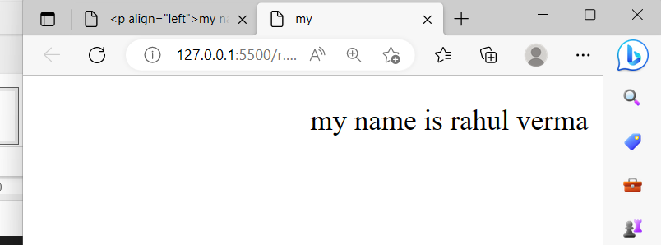

<!DOCTYPE html>

<html>

<body>

    <img src="Game.png" width="200" hight="300">

</body>

</html>

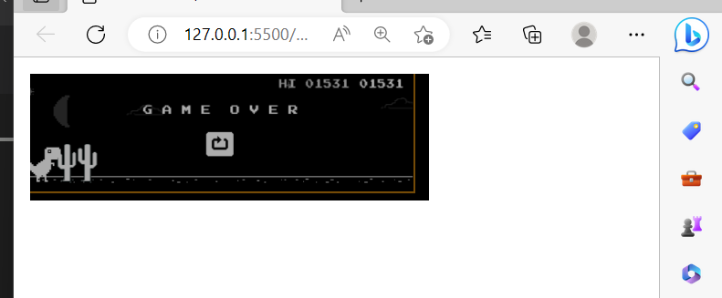

<!DOCYPTE html>

<html>

    <head>

        <title>file</title>

    </head>

    <body>

        <a href="#mathematic's">Mathematic's</a><br>

        <a href="#English">English</a><br>

        <a href="#Html">HTML</a><br>

        <a href="#c language">C LANGUAGE</a>

        <a name="mathematic's"><h2>Mathematic's<h2></h2></a>

        <p>Mathematic's Lorem ipsum dolor sit amet, consectetur adipisicing elit.<br><a href="n.html">top</a>

        </p>

        <a name="English"><h2>English</h2></a>

        <p><strong>English</strong>is the most <em>popular</em>Lorem ipsum dolor, sit amet consectetur adipisicing elit. .<br><a href="n.html">Top</a>

        </p>

        <a name="Html"><h2>html(<em>hyper test markup language</em>)</h2></a>

        <p><strong>html</strong> a shrothand for <i>hyper text markup language is one of the most important fundamental building blocks of the web.  <STRONG><a href="n.html">Top</a></STRONG></em></i>

        </p>

        <a name="c language"><H2>C LANGUAGE</H2></a>

        <p>in <em>1972</em> , c language is developed by denish richie for creating system applications such as driver, kernels etc <a href="n.html"><em>top</em></a></p>

    </body>

</html>

>

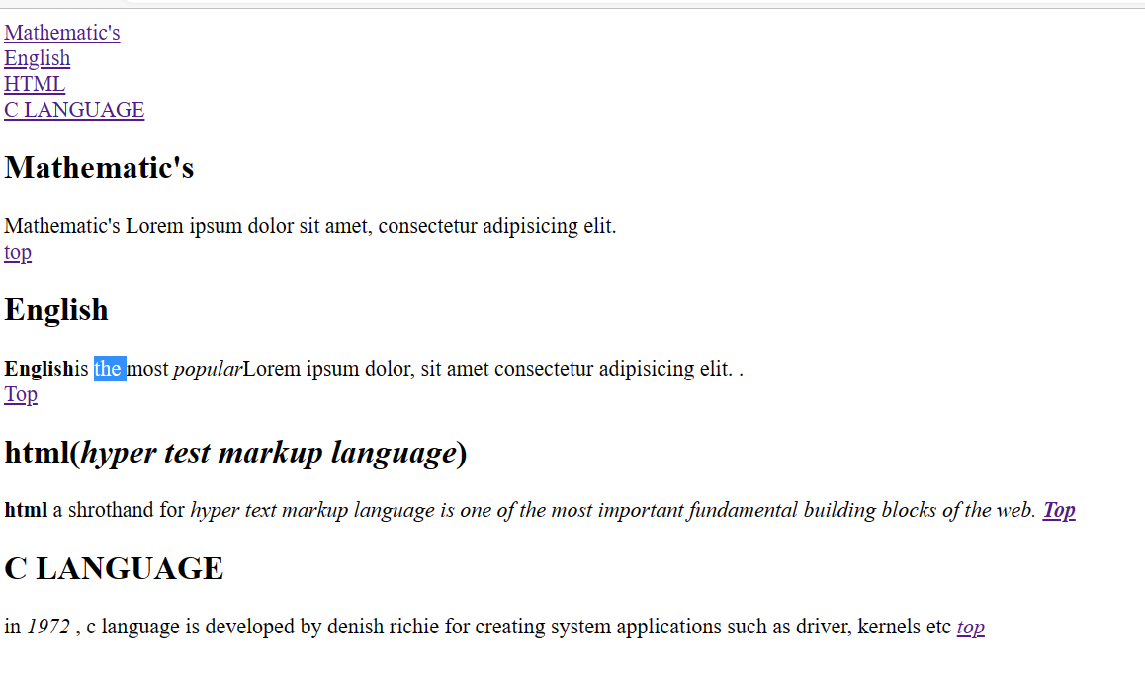<!DOCTYPE html>

<html>

    <head>

        <title>

            calcuter

        </title>

    </head><fieldset><legend> THIS IS A  CALCULATOR</legend>

    <form>

Enter the number : <input type="number" name="number"><br>

        <table >

            <tr><tb><button>9</button><button>8</button><button>7</button><button>%</button></tb></tr><br>

            <tr><tb><button>8</button><button>7</button><button>6</button><button>*</button></tb></tr><br>

            <tr><tb><button>3</button><button>2</button><button>1</button><button>/</button></tb></tr><br>

            <tr><tb><button>=</button><button>+</button><button>-</button><button>Mg</button></tb></tr><br>

        </table>

    </form></fieldset>

</html>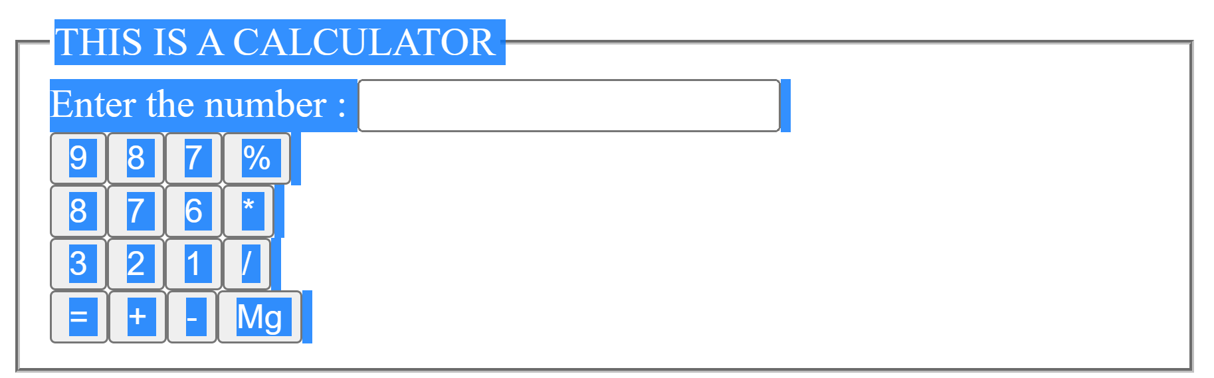

<!DOCTYPE html>

<html>

    <head>

        <title>

       pratices

        </title>

    </head>

    <body>

<form>

            <p>Name : <input type="text" name="name" id="text" required placeholder="Enter your name" >

            </p>

            <p> Phone Number :<input type="phone number" name="number" id="phone number" required placeholder="Enter your phone number"></p>

            <p>  Address : <textarea cols="40px" rows="3px"required placeholder="Enter your current address"></textarea>

                 </p><fieldset>

                    <legend align="center"> Gender</legend>

                  <p><label for="femal"> <input type="radio" name="gender" id="femal" vlaue="Female"required >Female </label><label for="male">

                 <input type="radio" name="gender" id="male" value=""Male" required >Male </label>

                </p></fieldset>

<fieldset>

                        <legend style="color: grey;">selected your subject for checkbox</legend>

                    <label for="Math"></p>

                        <p> <input type="checkbox" name="subject" value="Mathematic's" id="Math">Mathematic's</p>

                    </label>

                    <label for="C"></p>

                        <p> <input type="checkbox" name="subject" value="C language" id="C">C language</p>

                    </label>

                    <label for="hyper text markup language"></p>

                        <p> <input type="checkbox" name="subject" value="html" id="hyper text markup language">Html</p>

                    </label>

                    <label for="bc"></p>

                        <p> <input type="checkbox" name="subject" value="Buniess Communication" id="bc">Buniess Communicaion</p>

                    </label>

                    <label for="fundamental of computer"></p>

                        <p> <input type="checkbox" name="subject" value="foc" id="fundamental of computer">Foc</p>

<strong>selceted your city &nbsp;</strong>

        <select name="city" >

            <option value="Delhi">Delhi</option>

            <option value="Banglore">Banglore</option>

            <option value="Pune">Pune</option>

            <option value="Mumbai">Mumbai</option>

            <option value="Agra">Agra</option>

        </select>

                    </label>

                </fieldset>

                <p> Password : <input type="password" name="user passward" id="passward"required placeholder="Ener the passward" ></p>

                <p> E mail : <input type="Email" name="Email" id="passward"required placeholder="Enter the email"></p>

                <p> Pin code : <input : type="number" name="pin code" id=" code"required  placeholder="Enter the pin code">

                    <h3> payment detial's</h3>

                    <p> card type :

                        <select name="card_type" id="Card_type"required >

                            <option value="">--sected the card--</option>

                            <option value="mastercard">mastercard</option>

                            <option value="visa">upi</option>

                            <option value=" visa">visa</option>

                        </select>

                    </p>

                    <p> card number : <input type="number" name="card number" id="number"required placeholder="Enter your card number"></p>

                    <P> Expiration date : <input required type="date" name="Expiration date" id="Expiration date" ></P>

                    <p> cvv <input type="password" name="cvv" id="cvv" placeholder="Enter Card Verification Value"></p>

                    <p> <input TYPE="SUBMIT" value="pay"> </p>

                    <p> <input type="reset" name="reset" id="reset" required ></p>

                    <p> <input  type="submit" name="submit" id=" submit form"required >  </p>

                </p>

                </form>

            </body>

            <html>

